Biology: 10. Ecology
Please remember to photocopy 4 pages onto one sheet by going A3→A4 and using back to back on the photocopier

Syllabus
OB59 Study a local habitat, using appropriate instruments and simple keys to show the variety and distribution of named organisms

OB60 Understand that living things are affected by their environment and respond to changes that occur in that environment, and understand that their numbers depend on the availability of food and the presence or absence of other organisms

OB61 List examples of producers, decomposers and consumers in an ecosystem

OB62 Select a food chain and a food web from a named habitat and identify examples of adaptation, competition and interdependence

OB63 Understand the importance of conservation, pollution and waste management to the environment, and identify ways in which living things contribute to these, both individually and as a community

OB64 Consider and discuss how human activity affects the environment, both positively and negatively (two examples in each case)

Student Notes
Habitat Study
Ecology is the study of the interactions between organisms and their environment

A habitat is an environment where an organism lives, e.g. a hedge or a meadow

To study a local habitat
Method
- Make a map of the habitat- mark in any distinctive physical features e.g. streams, trees, ponds, rock, paths etc.
- Physical factors such as soil pH, temp., amount of sunlight and rainfall can be included.
- Collect and identify plants/animals (using keys to identify various plants and animals).

Equipment used in a habitat study
Pitfall trap: collects small organisms that walk along the surface of the ground e.g. beetle, spiders, centipedes.

Beating tray: A stick is used to strike a leafy branch to knock small animals off onto a white cloth below.
Pooter: for small insects, spiders, mites from surfaces of leaves and leaf litter and for transfer from beating trays and nets into containers.

Line transect: used to show the distribution of a species across an area e.g. from shade to sun in a woodland - use rope with knots at 1 metre - record name and height of plant touching each mark.

Quadrats
Used to measure how frequently a plant species occurs in a habitat.
Throw at random (say 20 times), identify and count the percentage frequency of a plant (e.g. daffodils) as follows:
% Frequency = Number of quadrats in which daffodils were found multiplied by 5

Producers, consumers and decomposers

A producer is an organism which makes its own food

Examples: plants

A consumer is an organism which feeds off other organisms

Examples: herbivores, carnivores, omnivores.

A decomposer is a living organism that feeds on dead plants and animals

Examples: bacteria and fungi.

Food Chains and Food Webs

All organisms need energy to live. Sun is the primary source of energy.
Energy flows from one organism to the next by means of a food chain.

Food Chain
A food chain is a list of organisms in the order in which one is eaten by the other.

Example of a food chain from a forest habitat
1st 2nd 3rd
(producer) (primary consumer) (secondary consumer)
Grass → rabbit → fox

Food Web
A food web consists of two or more interlinked food chains

Neither the food chain or the food web should be confused with the following:
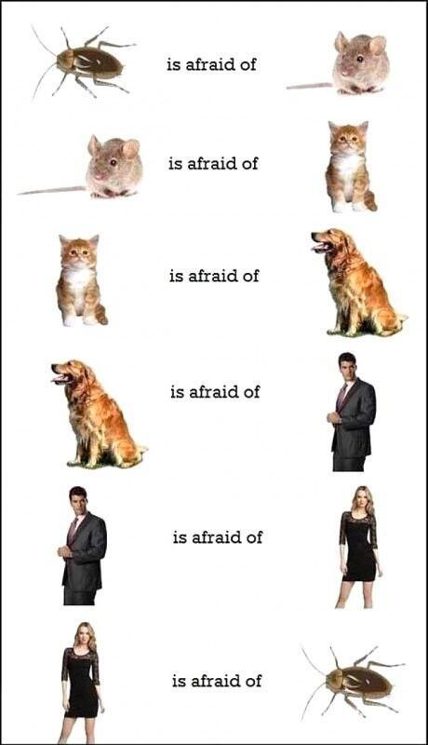
Adaptation, Competition and Interdependence in a food chain

Adaptation
Adaptation is the process where an organism becomes better suited to its environment

Examples of adaptation in a rabbit
- It is brown for camouflage.
- Long ears so it can detect the presence of its predators.

Examples of adaptation in plants
- Some plants have a nasty taste to deter predators e.g. giant hogweed.
- Bracken can grow in shade, grass cannot.

Competition
Competition is the struggle between organisms for a resource that is in short supply

Examples
Plants and animal compete for space, light, food, mate, water, minerals, shelter.

Interdependence
Interdependence is where two organisms rely on each other for some aspect of survival

Example
A plant relies on an insect for pollination while the insect relies on the plant for food.
Trees depend on birds for seed dispersal and the birds get shelter, nests, nuts and berries in return.

The size of a population depends on the availability of food and the presence or absence of other organisms

Living things are affected by their environment and respond to changes that occur in that environment

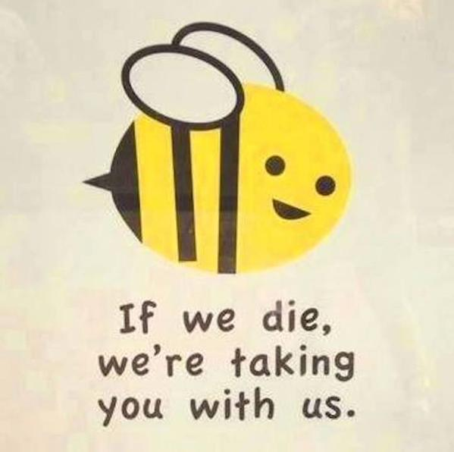
Looking after our environment; Pollution, Conservation and Waste Management

Pollution
Pollution is the process by which harmful substances are added to the environment by humans.
Examples
- Soil pollution
- Water pollution
- Air pollution
- Greenhouse effect

Conservation
Conservation is the preservation of the earth’s natural resources for the future.
Examples
- National parks
- Hedgerow and bogland conservation
- Listing of threatened species e.g. lizard, frog and stoat in Ireland
- Zoos and wildlife parks – by breeding endangered species

Waste Management
Waste management involves managing the disposal of our waste products
Examples
Reduce, Reuse, Recycle campaign
Compost bin – vegetable peelings and garden waste.
Incineration

Two negative effects of humans on the environment
- Air pollution
- Habitat destruction (e.g. deforestation, overhunting, etc)

Two positive effects of humans on environment
- Protection of endangered species
- Tree planting

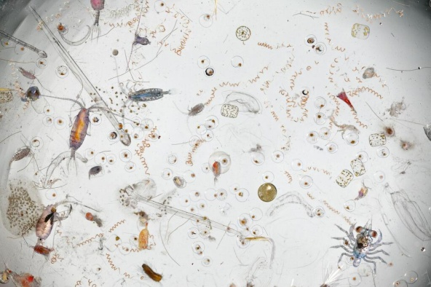
This is what a single drop of salt water looks like when magnified

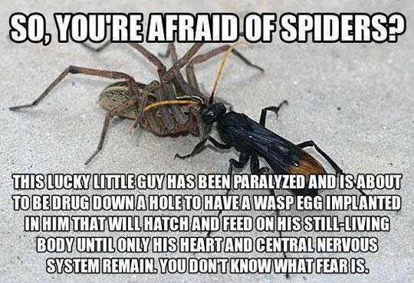

This moth has evolved to look like bird poo. It’s called the beautiful wood nymph…
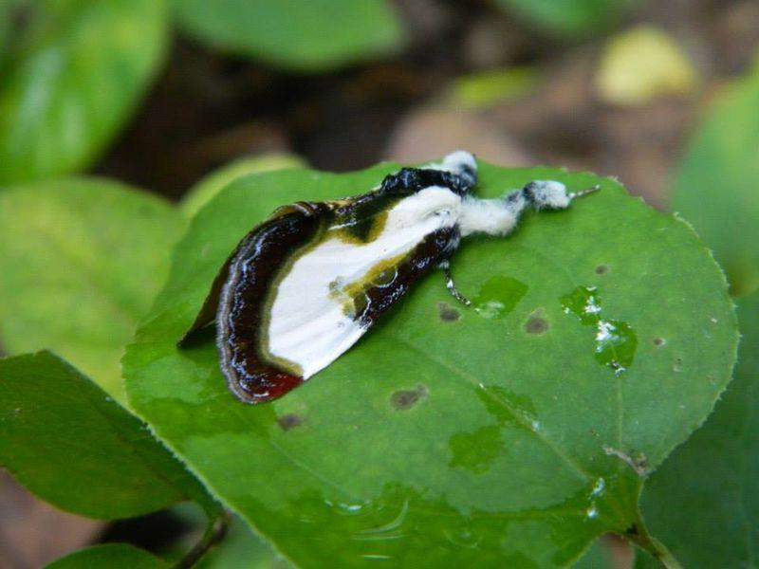

This guy is found in Japan. Any idea how it came to look like a fearsome warrior?

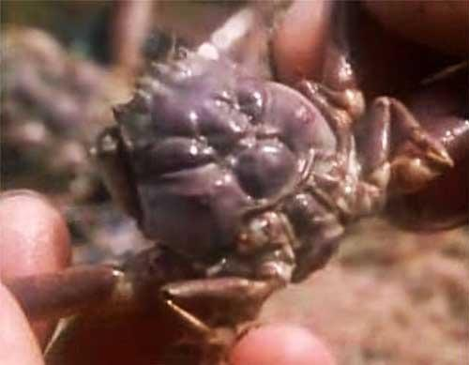

Exam Questions

Food Chain / Food Web
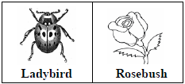
- [2011 OL]
Choose the correct organism from the list on the right to complete the food chain below.


- [2009 OL]
The food chain relates to a garden habitat.
Study it and answer the questions that follow.
- Name a producer in this food chain.
- Name a consumer in this food chain.
- Explain how the removal of ladybirds would affect the greenfly population in this habitat.
- [2008]
The diagram shows part of a food web from a mixed habitat with meadows, streams and hedges.
A is a dragonfly, B is a grasshopper, C is a butterfly
D is a house fly, E1, E2 and E3 are plants.
- Write down a food chain from the food web shown.
- Select an organism from this habitat or name another organism from a habitat you have studied and state one adaptation that the organism has that makes it suited to its habitat.
- What is meant by competition in a habitat?
- Give an example of interdependence from the food web shown.

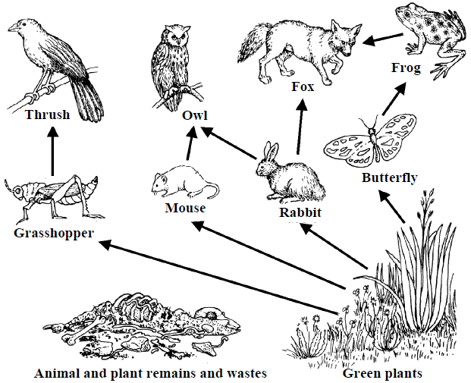
- [2011]
The diagram shows a simplified food web from a mixed habitat.
Answer the following questions using only items from the diagram above in your answers.

- Write a food chain with three members.
- Decomposers are not shown in the diagram.
What should decomposers feed on?
- Give one example of adaption.
- Name two animals that might be in competition.
- What is meant by the term interdependence.
- Give an example of interdependence.

Equipment
- [2008 OL][2010 OL]
The piece of equipment drawn on the right is used in ecology.
  - Name the piece of equipment.
  - Give one use for this piece of equipment.

- [2009]
The study of a habitat requires the use of sampling instruments, as it is not possible to count every individual organism living there.
A pupil and teacher are using a quadrat. The quadrat is placed randomly in a number of sites in the habitat being studied.
- How is random sampling achieved when using a quadrat?
- Give two different types of data collected (two different tasks performed) at each site in the habitat when using the quadrat.

- [2006 OL][2010 OL]
The piece of equipment drawn on the right is used in ecology.
- Name the piece of equipment.
- Give one use of this piece of equipment.
- [2007]
The diagram shows a pooter. Describe how to use a pooter.

- [2009]
Line transects are also used to sample habitats.
- What is a line transect?
- Describe how to sample a habitat using a line transect.

- [2009]
A sweep net is used to collect small animals e.g. insects from vegetation in a habitat so that they can be identified.
- Name a second item of equipment used to collect small animals for identification.
- Draw a labelled diagram, in the box provided, of the item that you have named in (i) above.
- Describe how to use the item that you have named and drawn.

- [2011 OL]
- Draw a diagram of a piece of equipment used by you to collect or trap insects or small animals when you were studying a habitat.
- Name the piece of equipment.
- Explain how it was set up or used.

- [2009]
Give two reasons why the groups of organisms living together can vary greatly from one part of a habitat to another.

- [2010]
The diagram shows a stickleback, a small fish that lives in our fresh water habitats. Give two adaptations that fish have to help them to live in water.

- [2008]
The photograph of ‘spaceship earth’ was taken by a member of the crew of Apollo 17.
Give two ways in which we can care for our planet.
- [2011][2006]
Waste management includes: composting, incineration, landfill and recycling.
Pick two of the underlined methods of managing waste and say how it works and give one advantage and one disadvantage of using the method that you have selected.

- [2007]
The increase in carbon dioxide concentration in the Earth’s atmosphere is currently causing concern.
The use of fossil fuels and deforestation have been identified as major contributors to this increase in carbon dioxide concentration. The graph shows a continual increase in the carbon dioxide concentration for the last fifty years. The data was collected at a site in Europe.

- Explain how either the use of fossil fuels or deforestation could have contributed to the increase in atmospheric carbon dioxide.
- Suggest one possible effect of continued increase in carbon dioxide concentration in the Earth’s atmosphere.
- Though there is an overall increase in carbon dioxide concentration there is an annual rise and fall in carbon dioxide concentration as shown in the box in the diagram.
Suggest one reason why the carbon dioxide concentration decreases between April and October each year.
- How could the reason that you have given in (iii) be used in a practical way to slow down and even reverse the overall increase in carbon dioxide levels in the atmosphere?

Exam Solutions
- Rosebush Aphid Ladybird

- Rosebush
- Aphid (greenfly) / ladybird / robin
- Greenfly population would increase

- e.g.
Plant/s → Primary consumer
Plant/s → mouse
Primary consumer → Secondary consumer
Mouse → Dog/ fox
- e.g. mouse has fur/ teeth/ ears/ legs…
- Living things (organisms) needing the same resource
- e.g. the butterflies depend on plants for food
Plants depend on butterflies for pollination
or
Plants use carbon dioxide and produce oxygen.
The mouse uses oxygen and produces carbon dioxide.
or
The mouse eats fruit and as a result helps to disperse seeds

- Any three organisms linked in the diagram starting with a green plant
e.g. green plant (grass), rabbit, fox
- Dead animals/ dead plants/ animal excretions/fallen leaves/ humus…
- Any adaptation linked to the diagram:
fur on fox (rabbit) (mouse),
wings on butterfly (owl) (thrush),
hind legs on grasshopper,
leaves on green plant…
- any two animals linked in the diagram:
e.g. owl and fox could compete for prey
- Living things (organisms) depend on each other
- Any two way relationship between organisms.
e.g. butterflies pollinate and get food from the flowers.
Birds eat fruit and disperse seeds.
Animals make CO₂ which is used by plants.
Plants make O₂ which is used by animals.

- LQuadrat
- Estimating (counting ) plants

- It is thrown over the shoulder.
- We noted the names of different types of plants present.
We noted the number ((% frequency) of each plant present.

- Pooter
- Collecting / sucking up / small animals (insects )
- Put tube B over the small animal and suck tube A

- A transect is a length of string or rope with a mark or knot every metre.
- Lay the string across the area to be sampled.
Identify every plant present at each metre mark.

- Pooter/ pitfall trap/ beating tray/ Tullgren funnel/ plankton net/ small mammal trap...
- See drawing of a pooter.
- Place Tube A over the insect you wish to collect and suck through Tube B to suck the insect into the container.

- Correct diagram of pooter, pitfall trap, (sweeping) net, etc
- Correct name
- Correct description

- Presence of herbivores/ presence of carnivores/ presence of insects for pollination/ presence of nitrogen fixers/ type of soil/ soil drainage/ minerals in soil/ pH of soil/ air content of soil/ amount of humus in soil/ water content of soil / light levels/ exposure to wind/ exposure to frost/ elevation/ salinity/ aeration of water/ currents in water/ competition/ coniferous trees/ deciduous trees...
- Gills/ fins/ scales/ spines/ shape (streamlined)/ tail/ colour (camouflage) / lateral line…
- Reduce burning of fossil fuels/ reduce release of sulfur (nitrogen) oxides/ reduce release of CFCs/ use only unleaded petrol/ reduce release of dioxins/ use smokeless fuels/ treat sewage/ avoid slurry spills/ dispose of waste properly/ recycle/ reuse/ plant trees /stop deforestation/ maintain biodiversity…
- Composting: plant (food) wastes are allowed to rot; safe/ useful product/ reduces use of landfill/ slow/ composter required…
Incineration: waste is burnt; toxic (medical) waste made safe/ possible air pollution…
Landfill: waste is put into the ground; quick/ leaching (effluent)/ long term management required…
Recycling: waste material is made into new items/ re-used/ saves resources/ doesn’t go into landfill/ infrastructure (recycling plants) required…

- Burning releases carbon dioxide (CO₂)
or
Deforestation results in less carbon dioxide being used/ less photosynthesis/ burning forests releases CO₂
- Acidification of rivers (lakes) (seas) / melting of polar ice (glaciers)/ rise in sea levels / drought/ greenhouse effect/ disruption of aquatic food chains/ climate change/ changes in ocean currents/ extinction of species/ global warming…
- Carbon dioxide (CO2) is taken in by plants/ used in photosynthesis/ more leaves/ less fuel is burnt for heating…
- Plant more trees (reforestation) / by increasing photosynthesis/ burn less fuel/ turn down thermostats/ better heat insulation of houses/ heat pump/ bio-fuel/ solar panels…

Other Test Questions
- What is ecology?

- What is a producer? Give two examples.

- What is a decomposer? Give two examples.

- What is a consumer? Give two examples.

- List a habitat which you have studied and identify a food chain and a food web from it.

- Identify examples of adaptation, competition and interdependence from the habitat you mentioned above.

- Why do organisms need to compete with each other?

- What is (i) a herbivore, (ii) a carnivore, (iii) an omnivore? Give an example of each.

Adaptation
Chameleon, octopus. Evoution
Adaptation
10 fingers,
Two ekyes,
Ears
Kidneys
Come up with 20 more for homework
If engineers were to start again . . .
Sometimes get it wrong

The degeneracy of a parasite is as perfect as the human brain.

